

RestroMation

Final Project – Team 2

GitHub: <https://github.com/harshilr/Restaurant_Automation>

Cégep de la Gaspésie et des Îles

Mobile Application Development

Team - 2 Members:

Himanshu Shah - 1896502

Urvil Shah - 1896494

Harshil Ramswaroop - 1896362

Avtar Singh -1896909

Amardeep Kaur - 1895889

Table of Content

**1) Introduction** 4

**2) Project Description** 4

2.1) Planned Sprint Timeline 4

2.1) Users and Roles 5

2.1.1) Primary Users 5

2.2) Roles 5

2.2.1) Customer Roles 5

2.2.2) Manager Roles 6

2.2.3) Chef Roles 6

2.2.4) Cashier Roles 7

2.3) Glossary of Terms 7

**3) Requirements** 7

3.1) Software Requirements 7

3.1.1) Functional Requirements 7

3.1.2) Non- Functional Requirements 7

3.2) User Requirements 8

3.2.1) User Story 8

3.3) User Story Backlog 17

**4) Planned User Stories** 20

4.1) Sprint 1 20

4.2) Sprint 2 21

4.2) Sprint 3 23

**5) Use Case Diagram** 25

5.1) Use case Diagram (Employee Side) 25

5.1.1) Fully Dressed Use Case (Employee side) 26

5.2) Use case Diagram (Customer Side) 31

5.2.1) Fully Dressed Use Case (Customer side) 32

**6) Sequence Diagram** 36

6.1) Customer 36

6.2) Manager 37

6.2) Chef 38

6.4) Cashier 39

**7) Activity Diagram** 40

7.1) Customer 40

7.2) Employee 41

**8) Mock-ups** 42

8.1) Customer side 42

8.1.1) Splash Screen 42

8.1.2) Login Screen 42

8.1.3) Forgot Password 43

8.1.4) Register Screen 43

8.1.5) Reservation Screen 44

8.1.6) Cart 45

8.1.7) Menu Items 45

8.1.8) Payment screen 46

8.1.9) Order History 46

8.2) Manager Side 47

8.2.1) Manager Dashboard 47

8.2.2) Order history 47

8.2.3) Menu items 48

8.2.4) Table History 48

8.2.5) Add Menu Item 49

8.2.6) Add employee 49

**9) Class Diagram** 50

**10) Database Schema Diagram** 51

**Table of Figures**

Figure 1: Use Case (Employee Side) 25

Figure 2: use case (customer) 31

Figure 3: sequence diagram (Customer) 36

Figure 4: sequence diagram (Manager) 37

Figure 5: sequence diagram (Chef) 38

Figure 6: sequence diagram (cashier) 39

Figure 7: activity diagram (Customer) 40

Figure 8: activity diagram (employee) 41

Figure 9: splash screen 42

Figure 10: Login screen 42

Figure 11: Register Screen 43

Figure 12: Forgot password 43

Figure 13: Reservation screen 44

Figure 14: menu items 45

Figure 15: Cart 45

Figure 16: order history 46

Figure 17: payment screen 46

Figure 18: manager dashboard 47

Figure 19: order history 47

Figure 20: table history 48

Figure 21: menu item 48

Figure 22: Add employee 49

Figure 23: Add menu Item 49

Figure 24: Class Diagram 50

Figure 25: Database Schema Diagram 51

# **1) Introduction**

The purpose of this project is to create an Android Mobile Application which will be used to let the user reserve a table and order food for a restaurant. This application aims at helping the employees to manage the crowd and ease up the working in a restaurant.

Mainly, the Employees and the customers will be the primary users of the application. These users will depend on the app to reserve a table and order food, and on the other side the employees will use the app to process orders and track the status of tables and ordered items by the customers.

The purpose of this documentation is to define the overall project specification as well as the general information of the prototype development. In this case, the targeted readers of the document are the stakeholders, which are interested in the development of the application as well as the developers that will be creating the app.

# **2) Project Description**

Restaurant Automation system is a Mobile application which helps the management of the restaurant easily. In other words, it reduces the manpower, increases accuracy, and makes it easy for the manager to manage the crowd easily. It is an easy to use application in this modern-day world, which will make life easy for both customers and the employees of the restaurant.

Throughout the development of the application, we will be following on the Agile Scrum framework. The project will be divided into several sprints, each building on top of the previous one. Each sprint will be divided into two-week iterations. After the completion of each sprint, we will present our progress on the application and our plan for the upcoming sprint.

## 2.1) Planned Sprint Timeline

|  |  |  |  |
| --- | --- | --- | --- |
| Sprint | New Deliverables | Start Date | End Date |
| 1 | * Software Architecture Document * User Stories Backlog * Sprint 1 planning * UI modelling of key components * Database Creation * API for authentication | May 5, 2020 | May 17,2020 |
| 2 | * API for main functionality * Completing user stories * Summary Report * Sprint 2 planning * UI Modelling of sprint 2 user stories | May 18th, 2020 | June 31st 2020 |
| 3 | * API creation for functionality * Sprint 3 planning * Completing user stories * UI Modelling of sprint 3 user stories | June 1st 2020 | June 14th 2020 |
| 4 | * Testing * Solving minor errors and bugs * Ui modelling | June 15th 2020 | June 28th2020 |

## 2.1) Users and Roles

### 2.1.1) Primary Users

* Customer
* Manager
* Cashier
* Chef
* Admin

## 2.2) Roles

### 2.2.1) Customer Roles

* Able to create an account (Register).
* Able to login using email and password.
* Will have an option to recover password
* Will have the option to change password.
* Can register into an application by providing following details
  + First Name
  + Last Name
  + Email
  + Password
* Can reserve a table for a particular number of people. (If the table is not available, you can see the average waiting time for a table).
* Can reserve more than one table, maximum 2.
* Can add multiple menu items to the cart.
* Select payment option through a card or at the counter.
* Options Dine in or Takeout.
* Gets notification of the available table.
* Delete the account.
* Logout of the account.
* Give feedback/review.

**Role Description:**

The customer opens the app and signs up to the app providing their name, email, mobile no. and password. If the customer is already signed up he/she logs in to the app with their email and password.

Once logged in they can book a table in the restaurant based on the number of people.

If available the app will assign them a table and reserve it for them. If not available, average waiting time will be shown to them.

After booking a table the customer will be able to see the menu on the home screen. Menu Items are divided according to their category. They can add food items to the cart with the quantity. Once all the desired items are added to the cart, the customers then, can proceed to order the food from the cart. They can choose the type of payment, either paying by card or   pay at the counter. They can also choose to DINE IN or to take away the food.

### 2.2.2) Manager Roles

* Can login to the app using email and password
* Can change the password
* Add an employee. As per the role.
* See the status of all the tables (reserved and available).
* Add items into the menu based on category.
* See all the menu items of the menu.
* Change price of a menu item.
* Logout.
* See the list of employees.
* Modify employee’s data.
* Add tables based on capacity.

**Role Description:**

If the manager logs in to the app, he/she has various manipulation options.

The app allows the manager to add/remove or change the status of the table (available/reserved), add/remove employees.

Moreover, it shows the status of all the tables in the restaurant.

Managers can also add, remove or update the menu Items from the menu

### 2.2.3) Chef Roles

* Login using email and password
* Change password
* Gets Notification for any order.
* See the type of order (Dine in or Takeout).
* See the order details (Items, Table number).
* Change status of order.
* Can change the menu Item Status (Available or not available)
* Logout.

### 2.2.4) Cashier Roles

* Check the status of order payment.
* Handle cash payments.
* Change status of payments. (Paid or not).
* Only handle take out - if paid.

# 2.3) Glossary of Terms

Some of the terms have different types and should be strictly followed.

* User Type: Customer, Manager, Chef, Cashier, Admin
* Menu Item Status: Available or Not Available
* Order Status: Ordered, in process, Complete, Cancelled
* Table Status: Reserved or Available
* Order Type: Dine in or Takeout
* Menu Category: Appetisers, main course, Dessert, Beverages
* Payment Type: Cash or Card

# **3) Requirements**

## 3.1) Software Requirements

### 3.1.1) Functional Requirements

* Users can login/register to the app.
* Customers must be able to reserve a table.
* The application must allow the customers to order food
* A cart must be created to add the desired items.
* Customers must be notified if a table is available.
* Chef should be notified if a new order has been added.
* The manager should be able to track/change the status of a table, add/change items to the menu, add employees.
* Cashiers must be able to change the payment status of the order and generate bills.

### 3.1.2) Non- Functional Requirements

* **Recoverability**: The app should automatically sign in the user every time he/she opens the app.
* **Data Integrity**: The app should show accurate and consistent data.
* **Usability**: The ease of use and learning to adapt the system should be satisfying to the user.
* **Security**: In case of malicious attack on the system, the system should function correctly.

-The users should be kept safe.

- Users info like personal contact, payment methods should be protected

* **Reliability**: The probability of failure free system must be higher and should be improved on a developmental basis
* **Data Efficient**: The app should be low-data consuming and still it should provide all the functionalities in low data.
* **Capacity:** The application should be able to handle 1000 booking requests simultaneously.
* **Scalability:** when the user data increases the app should be capable of handling them without delay by optimising the way storage is done and accessed.
* **Network:** The app should be able to look out for WiFi if not available than automatically switch to Mobile network.
* **Performance:** The app should be able to load the food menu within 5 seconds with all thumbnail Images.
* **Reliability:** The app should not make wrong order at the restaurant end.
* **Availability:** A new update of application shall be available for first‐time use within 24 hours of the start of the install.

-Unless the application is non‐operational, the application shall present a user with notification informing them that the application gets something new.

* **Efficiency: At** least 20 percent of the processor capacity and storage space available to the system shall be unused at peak load seasonal periods.

-Any interface between a user and the automated system shall have a maximum   response time of two seconds.

* **Flexibility:** The billing system shall be able to process payments in multiple different currencies.
* **Install ability:** When a new version of the main system is released, it shall be possible to upgrade to it from any previous version.

-Installing an upgrade shall not modify existing configuration values.

## 3.2) User Requirements

### 3.2.1) User Story

|  |  |
| --- | --- |
| User Story ID: | RM- 01 |
| Name: | as a user I want to register myself into the system |
| User Story Points: | 5 |
| Priority: | High |
| Description: |  |

|  |  |
| --- | --- |
| User Story ID: | RM- 02 |
| Name: | As a user I want to book a table to confirm my seat in restaurant. |
| User Story Points: | 3 |
| Priority: | moderate |
| Description: |  |

|  |  |
| --- | --- |
| User Story ID: | RM-03 |
| Name: | as a user I want to see the menu of the restaurant so that I can order food |
| User Story Points: | 8 |
| Priority: | High |
| Description: |  |

|  |  |
| --- | --- |
| User Story ID: | RM- 04 |
| Name: | as a user I want a notification once my table is booked |
| User Story Points: | 1 |
| Priority: | Low |
| Description: |  |

|  |  |
| --- | --- |
| User Story ID: | RM-05 |
| Name: | as a user I want to select multiple item from the menu |
| User Story Points: | 1 |
| Priority: | Low |
| Description: |  |

|  |  |
| --- | --- |
| User Story ID: | RM-06 |
| Name: | as a user I want a cart in which I can see all the items I have selected so that I can procced further with order |
| User Story Points: | 3 |
| Priority: | Low |
| Description: |  |

|  |  |
| --- | --- |
| User Story ID: | RM-07 |
| Name: | as a user I want access to manipulate items into the cart so that I can add and delete or update the quantity |
| User Story Points: | 3 |
| Priority: | Low |
| Description: |  |

|  |  |
| --- | --- |
| User Story ID: | RM-08 |
| Name: | As a user I want multiple payment option after I place the order so that I can pay the bill. |
| User Story Points: | 1 |
| Priority: | Low |
| Description: |  |

|  |  |
| --- | --- |
| User Story ID: | RM-09 |
| Name: | as a user I want to see the order I have already placed |
| User Story Points: | 1 |
| Priority: | Low |
| Description: |  |

|  |  |
| --- | --- |
| User Story ID: | RM-10 |
| Name: | as a user I want notification once my order is confirmed and status is changed |
| User Story Points: | 1 |
| Priority: | Low |
| Description: |  |

|  |  |
| --- | --- |
| User Story ID: | RM-11 |
| Name: | as a user I want to able to logout from the application |
| User Story Points: | 1 |
| Priority: | Low |
| Description: |  |

|  |  |
| --- | --- |
| User Story ID: | RM-12 |
| Name: | as a user I want to see the details of the restaurant so that I can see amenities provided by restaurant |
| User Story Points: | 3 |
| Priority: | Moderate |
| Description: |  |

|  |  |
| --- | --- |
| User Story ID: | RM-13 |
| Name: | As a user I want to select my dining option before I place my order. |
| User Story Points: | 5 |
| Priority: | Moderate |
| Description: |  |

|  |  |
| --- | --- |
| User Story ID: | RM-14 |
| Name: | As a Manager, I want to add Employees so that new employees can access the application. |
| User Story Points: | 8 |
| Priority: | High |
| Description: |  |

|  |  |
| --- | --- |
| User Story ID: | RM-15 |
| Name: | As a Manager, I want to modify and delete employees to make updated data available for employees. |
| User Story Points: | 3 |
| Priority: | Low |
| Description: |  |

|  |  |
| --- | --- |
| User Story ID: | RM-16 |
| Name: | As a Manager, I want to add menu items so that users can view new items. |
| User Story Points: | 5 |
| Priority: | Moderate |
| Description: |  |

|  |  |
| --- | --- |
| User Story ID: | RM-17 |
| Name: | As a Manager, I want to modify and delete Menu Items so that Menu Items are up-to-date. |
| User Story Points: | 3 |
| Priority: | Low |
| Description: |  |

|  |  |
| --- | --- |
| User Story ID: | RM-18 |
| Name: | As a Manager, I want to add Tables so that tables are available for use by customers. |
| User Story Points: | 3 |
| Priority: | Moderate |
| Description: |  |

|  |  |
| --- | --- |
| User Story ID: | RM-19 |
| Name: | As a Manager, I want to modify and delete tables so that updated information is available regarding tables. |
| User Story Points: | 3 |
| Priority: | Low |
| Description: |  |

|  |  |
| --- | --- |
| User Story ID: | RM-20 |
| Name: | As a manager, I want to see orders history & their current status of the restaurant. |
| User Story Points: | 5 |
| Priority: | Moderate |
| Description: |  |

|  |  |
| --- | --- |
| User Story ID: | RM-21 |
| Name: | As a manager, I want to see table’s history & their current status of the restaurant. |
| User Story Points: | 1 |
| Priority: | Low |
| Description: |  |

|  |  |
| --- | --- |
| User Story ID: | RM-22 |
| Name: | As a Cashier, I want to Check status of payment to verify the payment status. |
| User Story Points: | 5 |
| Priority: | Moderate |
| Description: |  |

|  |  |
| --- | --- |
| User Story ID: | RM-23 |
| Name: | As a Cashier, I want to see all the bills of restaurants of each tables. |
| User Story Points: | 1 |
| Priority: | Low |
| Description: |  |

|  |  |
| --- | --- |
| User Story ID: | RM-24 |
| Name: | As a Cashier, I want to modify payment status to make updated status of payment available. |
| User Story Points: | 5 |
| Priority: | Moderate |
| Description: |  |

|  |  |
| --- | --- |
| User Story ID: | RM-25 |
| Name: | As a Chef, I want to get Notifications when a new order is placed. |
| User Story Points: | 8 |
| Priority: | High |
| Description: |  |
| User Story ID: | RM-26 |
| Name: | As a Chef, I want to see the type of order so as to make sure to pack it for take-out or for serving inside the restaurant. |
| User Story Points: | 5 |
| Priority: | Moderate |
| Description: |  |

|  |  |
| --- | --- |
| User Story ID: | RM-27 |
| Name: | As a Chef, I want to see the Order Details so as to prepare the order. |
| User Story Points: | 3 |
| Priority: | Low |
| Description: |  |

|  |  |
| --- | --- |
| User Story ID: | RM-28 |
| Name: | As a Chef, I want to access to change the status of the order. |
| User Story Points: | 5 |
| Priority: | Moderate |
| Description: |  |

## 3.3) User Story Backlog

## 

|  |  |  |  |
| --- | --- | --- | --- |
| ID | Name | USP | Priority |
| RM-01 | as a user I want to register myself into the system | 5 | High |
| RM-02 | as a user I want to book a table in the restaurant | 3 | Moderate |
| RM-03 | as a user I want to see the menu of the restaurant so that i can order food | 8 | High |
| RM-04 | as a user I want a notification once my table is booked | 1 | low |
| RM-05 | as a user I want to select multiple item from the menu | 1 | low |
| RM-06 | as a user I want a cart in which I can see all the items i have selected so that I can procced further with order | 3 | low |
| RM-07 | as a user I want access to manipulate items into the cart so that I can add and delete or update the quantity | 3 | low |
| RM-08 | As a user I want multiple payment option after i place the order so that I can pay the bill. | 1 | low |
| RM-09 | as a user I want to see the order I have already placed | 1 | low |
| RM-10 | as a user I want notification once my order is confirmed and status is changed | 1 | low |
| RM-11 | as a user I want to able to logout from the application | 1 | low |
| RM-12 | as a user I want to see the details of the restaurant so that I can see amenities provided y restaurant | 3 | moderate |
| RM-13 | As a user I want to select my dining option before I place my order. | 5 | moderate |
| RM-14 | As a Manager, I want to add Employees so that new employees can access the application. | 8 | high |
| RM-15 | As a Manager, I want to modify and delete employees to make updated data available for employees. | 3 | low |
| RM-16 | As a Manager, I want to add menu items so that users can view new items. | 5 | moderate |
| RM-17 | As a Manager, I want to modify and delete Menu Items so that Menu Items are up-to-date. | 3 | low |
| RM-18 | As a Manager, I want to add Tables so that tables are available for use by customers. | 3 | moderate |
| RM-19 | As a Manager, I want to modify and delete tables so that updated information is available regarding tables. | 3 | low |
| RM-20 | As a manager, I want to see orders history & their current status of the restaurant. | 5 | moderate |
| RM-21 | As a manager, I want to see table’s history & their current status of the restaurant. | 1 | low |
| RM-22 | As a Cashier, I want to Check status of payment to verify the payment status. | 5 | moderate |
| RM-23 | As a Cashier, I want to see all the bills of restaurants of each tables. | 1 | low |
| RM-24 | As a Cashier, I want to modify payment status to make updated status of payment | 5 | moderate |
| RM-25 | As a Chef, I want to get Notifications when a new order is placed. | 8 | High |
| RM-26 | As a Chef, I want to see the type of order so as to make sure to pack it for take-out or for serving inside the restaurant. | 5 | moderate |
| RM-27 | As a Chef, I want to see the Order Details so as to prepare the order. | 3 | low |
| RM-28 | As a Chef, I want to access to change the status of the order. | 5 | moderate |
|  | Total USP | 99 |  |

# **4) Planned User Stories**

## 4.1) Sprint 1

This sprint is concentrated on the manager side of application, all the main functionalities that manger will perform and uses, will be covered up in this sprint, Api for the functionality manger will perform will be developed, Ui modelling will also be created for manager side during this sprint.

|  |  |  |  |  |
| --- | --- | --- | --- | --- |
| Epic | User Story | Story Points | Priority | Status |
| RM-S-01 | **RM-14**  As a Manager, I want to add Employees so that new employees can access the application. | 8 | High | Done |
| **RM-15**  As a Manager, I want to modify and delete employees to make updated data available for employees | 3 | LOW | Done |
| **RM-16**  As a Manager, I want to add menu items so that users can view new items. | 5 | Moderate | Done |
| **RM-17**  As a Manager, I want to modify and delete Menu Items so that Menu Items are up-to-date. | 3 | low | Done |
| **RM-18**  As a Manager, I want to add Tables so that tables are available for use by customers. | 3 | moderate | Done |
| **RM-19**  As a Manager, I want to modify and delete tables so that updated information is available regarding tables. | 3 | low | Done |

|  |  |
| --- | --- |
| Completed User Story Points | 25 |

## 4.2) Sprint 2

This sprint is concentrated on the Customer side of application, all the main functionalities that Customer will perform and uses, will be covered up in this sprint, Api for the functionality Customer will perform will be developed, Ui modelling will also be created for Customer side during this sprint.

|  |  |  |  |  |
| --- | --- | --- | --- | --- |
| Epic | User Story | Story Points | Priority | Status |
| RM-S-02 | **RM-02**  as a user I want to book a table in the restaurant | 3 | Moderate | Done |
| **RM-03**  as a user I want to see the menu of the restaurant so that i can order food | 8 | High | Done |
| **RM-04**  as a user I want a notification once my table is booked | 1 | low | Done |
| **RM-05**  as a user I want to select multiple item from the menu | 1 | low | Done |
| **RM-06**  as a user I want a cart in which I can see all the items i have selected so that I can procced further with order | 3 | low | Done |
| **RM-07**  as a user I want access to manipulate items into the cart so that I can add and delete or update the quantity | 3 | low | Done |
|  | **RM-08**  As a user I want multiple payment option after i place the order so that I can pay the bill. | 1 | low | Done |
|  | **RM-09**  as a user I want to see the order I have already placed | 1 | low | Done |
|  | **RM-10**  as a user I want notification once my order is confirmed and status is changed | 1 | low | Done |
|  | **RM-11**  as a user I want to able to logout from the application | 1 | low | Done |
|  | **RM-12**  as a user I want to see the details of the restaurant so that I can see amenities provided y restaurant | 3 | moderate | Done |
|  | **RM-13**  As a user I want to select my dining option before I place my order. | 5 | moderate | Done |

|  |  |
| --- | --- |
| Completed User Story Points | 31 |

## 4.2) Sprint 3

This sprint is concentrated on the Chef and Cashier side of application, all the main functionalities that Chef and Cashier r will perform and uses, will be covered up in this sprint, Api for the functionality Chef and Cashier will perform will be developed, Ui modelling will also be created for Chef and Cashier side during this sprint. Also some functionality of manager is also covered in this sprint which were pending and needed some data which will come customer side.

|  |  |  |  |  |
| --- | --- | --- | --- | --- |
| Epic | User Story | Story Points | Priority | Status |
| RM-S-03 | **RM-20**  As a manager, I want to see orders history & their current status of the restaurant. | 3 | moderate | Done |
| **RM-21**  As a manager, I want to see table’s history & their current status of the restaurant. | 8 | low | Done |
| **RM-22**  As a Cashier, I want to Check status of payment to verify the payment status. | 1 | moderate | Done |
| **RM-23**  As a Cashier, I want to see all the bills of restaurants of each tables. | 1 | low | Done |
| **RM-24**  As a Cashier, I want to modify payment status to make updated status of payment | 3 | moderate | Done |
| **RM-25**  As a Chef, I want to get Notifications when a new order is placed. | 3 | High | Done |
|  | **RM-26**  As a Chef, I want to see the type of order so as to make sure to pack it for take-out or for serving inside the restaurant. | 1 | moderate | Done |
|  | **RM-27**  As a Chef, I want to see the Order Details so as to prepare the order. | 1 | low | Done |
|  | **RM-28**  As a Chef, I want to access to change the status of the order. | 1 | moderate | Done |

|  |  |
| --- | --- |
| Completed User Story Points | 22 |

# **5) Use Case Diagram**

5.1) Use case Diagram (Employee Side)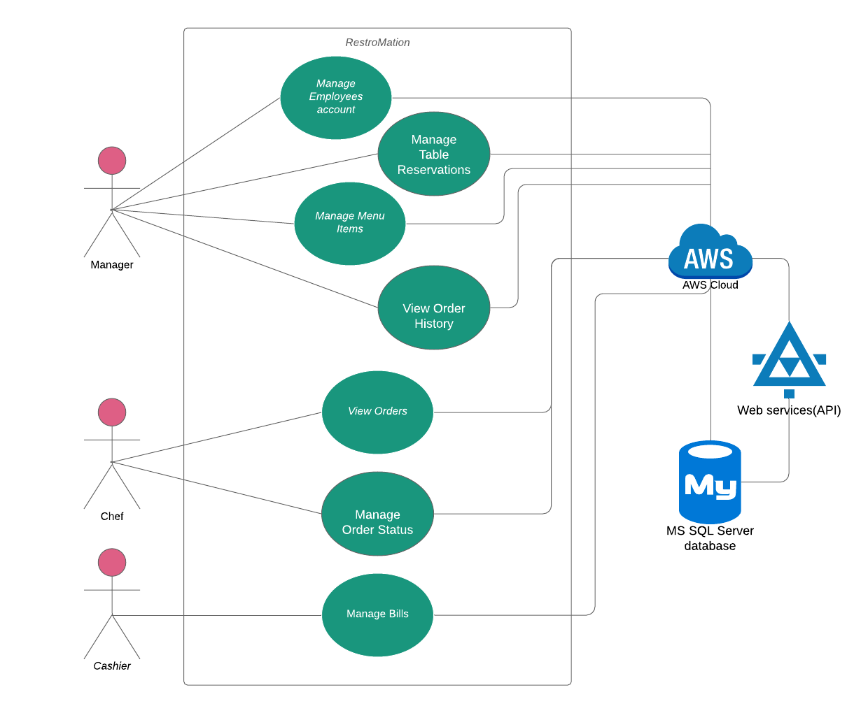

Figure 1: Use Case (Employee Side)

### 5.1.1) Fully Dressed Use Case (Employee side)

Manage Employee Account

|  |  |
| --- | --- |
| **Use case section** | **Comments** |
| **Use case Name** | Manage Employee Account |
| **Level** | Manager-Level |
| **Primary Actor** | Manager |
| **Stakeholder and Interest** | Manager: As a manager, I want all the data from the database, So that, I can add, update and remove any employee from database. |
| **Preconditions** | - Only Manager can manage employee account.  - Manager must have knowledge about handling database. |
| **Success Guarantee** | Manager can successfully add, modify, and remove any employee from database. |
| **Main Success Scenario** | **-**Manager can add and modify employee details.  -Manager can delete employee information if employee left job or fired. |
| **Extensions** | 1. If Manager cannot manage employees.     -Manager is not authenticated.  2. If there is any empty or invalid field, it will show error. |
| **Special requirements** | Device should connect to internet. |
| **Technology and Variants list** | This application can run in any android device.  Variants- MySQL, Visual studio |
| **Frequency of occurrence** | Could be nearly continuous. |

Manage Table Reservation

|  |  |
| --- | --- |
| **Use case section** | **Comments** |
| **Use case Name** | Manage Table Reservation |
| **Level** | Manager-Level |
| **Primary Actor** | Manager |
| **Stakeholder and Interest** | Manager: As a manager, I want all the data from the database, So that, I can manage table reservation, add, modify and delete table into database. |
| **Preconditions** | - Only Manager can manage reservation of table.  - Manager can change status of table.  - Manager must have knowledge about handling database. |
| **Success Guarantee** | Manager can successfully add, modify, and remove any table from database.  Manager can successfully change table status. |
| **Main Success Scenario** | **-**Manager can change status of table.  **-**Manager can add and modify table details.  -Manager can delete table information from database. |
| **Extensions** | 1. If Manager cannot manage table reservation.     -Manager is not authenticated.  2. If there is any empty or invalid field, it will show error. |
| **Special requirements** | Device should connect to internet. |
| **Technology and Variants list** | This application can run in any android device.  Variants- MySql, Visual studio |
| **Frequency of occurrence** | Could be nearly continuous. |

Manage Menu items

|  |  |
| --- | --- |
| **Use case section** | **Comments** |
| **Use case Name** | Manage Menu items |
| **Level** | Manager-Level |
| **Primary Actor** | Manager |
| **Stakeholder and Interest** | Manager: As a manager I want all the data from the database, So that, I can add, update and remove any menu item according to category from database. |
| **Preconditions** | - Only Manager can manage menu items.  - Manager must have knowledge about handling database. |
| **Success Guarantee** | Manager can successfully add, modify, and remove any menu item according to category into database. |
| **Main Success Scenario** | **-**Manager can add and modify menu items details.  -Manager can add new category of menu into DB.  -Manager can delete any menu items. |
| **Extensions** | 1. If Manager cannot manage menu items.     -Manager is not authenticated.  2. If there is any empty or invalid field, it will show error. |
| **Special requirements** | Device should connect to internet. |
| **Technology and Variants list** | This application can run in any android device.  Variants- MySql, Visual studio |
| **Frequency of occurrence** | Could be nearly continuous. |

 View Order History

|  |  |
| --- | --- |
| **Use case section** | **Comments** |
| **Use case Name** | View Order History |
| **Level** | Manager-Level |
| **Primary Actor** | Manager |
| **Stakeholder and Interest** | Manager: As a manager, I can view order history according to date, month and year. |
| **Preconditions** | - Only Manager can view history of orders. |
| **Success Guarantee** | -Manager can successfully view order history.  -Manager can choose time period of showing history. |
| **Main Success Scenario** | **-**Manger can go to view history screen. |
| **Extensions** | 1. If Manager cannot view table history.     -Manager is not authenticated.     - Error exception has occurred. |
| **Special requirements** | Device should connect to internet. |
| **Technology and Variants list** | This application can run in any android device.  Variants- MySql, Visual studio |
| **Frequency of occurrence** | Could be nearly continuous. |

View Orders

|  |  |
| --- | --- |
| **Use case section** | **Comments** |
| **Use case Name** | View Orders |
| **Level** | Chef-Level |
| **Primary Actor** | Chef |
| **Stakeholder and Interest** | Chef: As a chef, I want to be able to view all orders with remaining time. So that, I can prepare orders according to time. |
| **Preconditions** | -The database is up and running.  - All orders have to send to chef's screen.  - Chef can view orders. |
| **Success Guarantee** | -All new orders would successfully send to chef's screen on time.  -Chef can successfully remove done order from queue. |
| **Main Success Scenario** | -Chef can view all new orders on time.  -Chef can view all orders according to priority(Older one on top and latest in bottom)  -Chef can view order queue and wait queue from the database. |
| **Extensions** | 1. If Chef cannot view orders.     -Chef is not authenticated.     -Slow server     -Error exception has occurred. |
| **Special requirements** | Device should connect to internet. |
| **Technology and Variants list** | This application can run in any android device.  Variants- MySql, Visual studio |
| **Frequency of occurrence** | Could be nearly continuous. |

Manage order status

|  |  |
| --- | --- |
| **Use case section** | **Comments** |
| **Use case Name** | Manage order status |
| **Level** | Chef-Level |
| **Primary Actor** | Chef |
| **Stakeholder and Interest** | Chef: As a chef, I want to be able to change the status of orders (Wait and done) |
| **Preconditions** | -The database is up and running.  - All orders should be displayed on chef's screen.  -Only chef can select an order to cook, and flag an order as done. |
| **Success Guarantee** | Chef can successfully change status of orders (Waiting or done) |
| **Main Success Scenario** | -Chef can select orders to cook and flag an order is done. |
| **Extensions** | 1. If Chef unable to manage order status.     -Chef is not authenticated.     -Slow server     -Error exception has occurred. |
| **Special requirements** | Device should connect to internet. |
| **Technology and Variants list** | This application can run in any android device.  Variants- MySql, Visual studio |
| **Frequency of occurrence** | Could be nearly continuous. |

 Manage Bills

|  |  |
| --- | --- |
| **Use case section** | **Comments** |
| **Use case Name** | Manage Bills |
| **Level** | Cashier-Level |
| **Primary Actor** | Cashier |
| **Stakeholder and Interest** | Cashier: As a cashier, I want to be able to manage bills (Cash/Card) of customer. So that, I can take payment.  -Wants accurate, fast entry, and no payment errors, as cash drawer shortages are deducted from his/her salary. |
| **Preconditions** | -The database is up and running.  -Cashier is identified and authenticated.  - All due payments should be displayed on cashier's screen.  -Only cashier can take payment and change status to PAID. |
| **Success Guarantee** | -Tax is correctly calculated.  - Accounting and Inventory are updated.  - Commissions recorded.  - Receipt is generated.  - Payment authorization approvals are recorded. |
| **Main Success Scenario** | -System presents receipt.  -. Customer leaves with receipt and goods (if any).  -Customer pays and System handles payment. |
| **Extensions** | 1. If cashier unable to manage Bills.     -Cashier is not authenticated.     -Slow server     -Error exception has occurred. |
| **Special requirements** | Device should connect to internet. |
| **Technology and Variants list** | This application can run in any android device.  Variants- MySQL, Visual studio |
| **Frequency of occurrence** | Could be nearly continuous. |

5.2) Use case Diagram (Customer Side)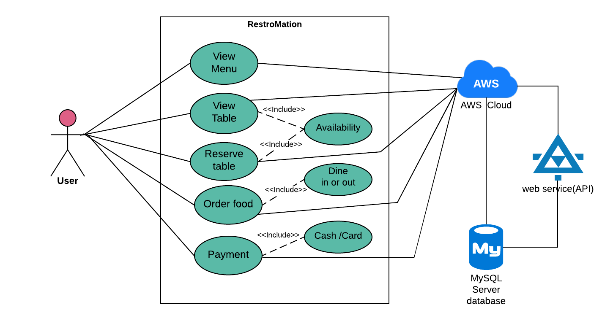

Figure 2: use case (customer)

### 5.2.1) Fully Dressed Use Case (Customer side)

View Menu

|  |  |
| --- | --- |
| **Use case section** | **Comments** |
| **Use case Name** | View Menu |
| **Level** | User-Level |
| **Primary Actor** | User |
| **Stakeholder and Interest** | User: As a user, I want to view menu according to food category items. So that, I can view all available menu items easily. |
| **Preconditions** | -The database is up and running. |
| **Success Guarantee** | -User Successfully land to menu screen.  . |
| **Main Success Scenario** | -Customer selects “View Menu” from the main screen.  - System displays a categorized list of food items available to order    based on ingredients available. |
| **Extensions** | 1. If user unable to View menu.     -User is not authenticated.     -Slow server     -Error exception has occurred. |
| **Special requirements** | Device should connect to internet. |
| **Technology and Variants list** | This application can run in any android device.  Variants- MySQL, Visual studio |
| **Frequency of occurrence** | Could be nearly continuous. |

View Table

|  |  |
| --- | --- |
| **Use case section** | **Comments** |
| **Use case Name** | View Table |
| **Level** | User-Level |
| **Primary Actor** | User |
| **Stakeholder and Interest** | User: As a user, I want to view all types of available tables list. So that, I can find a perfect table according to my requirement. |
| **Preconditions** | -The database is up and running. |
| **Success Guarantee** | -User Successfully can view list of available table and waiting for table. |
| **Main Success Scenario** | User can view all available tables and waiting tables list at a same time. |
| **Extensions** | 1. If user unable to View table.     -User is not authenticated.     -Slow server     -Error exception has occurred. |
| **Special requirements** | Device should connect to internet. |
| **Technology and Variants list** | This application can run in any android device.  Variants- MySQL, Visual studio |
| **Frequency of occurrence** | Could be nearly continuous. |

Reserve Table

|  |  |
| --- | --- |
| **Use case section** | **Comments** |
| **Use case Name** | Reserve Table |
| **Level** | User-Level |
| **Primary Actor** | User |
| **Stakeholder and Interest** | User: As a use, I want to view all types of available tables list. So that, I can reserve table according to my requirement. |
| **Preconditions** | -The database is up and running. |
| **Success Guarantee** | -User Successfully reserve one or multiple (no more than 3) available table. |
| **Main Success Scenario** | -Successful reservation of table is main success scenario. |
| **Extensions** | 1. If user unable to reserve table.    -Table must be available at time of reservation.     -User is not authenticated.     -Slow server     -Error exception has occurred. |
| **Special requirements** | Device should connect to internet. |
| **Technology and Variants list** | This application can run in any android device.  Variants- MySQL, Visual studio |
| **Frequency of occurrence** | Could be nearly continuous. |

Order Food

|  |  |
| --- | --- |
| **Use case section** | **Comments** |
| **Use case Name** | Order Food |
| **Level** | User-Level |
| **Primary Actor** | User |
| **Stakeholder and Interest** | User:  -As a user, I can selects food item of my choice and specifies the desired side meal.  -As a user, I want an option for Dine-in or Dine-out. So that, I can enjoy food in my comfort zone.  -As a user, when I finished adding meals, I can select “View Order” option.  -As a user, I can easily add food items into my cart. |
| **Preconditions** | -The database is up and running.  -User has placed the order.  -User can order only those food items which are available.  -User cannot modify cart items after order placed. |
| **Success Guarantee** | -User Successfully order multiple food items.  -User can modify their order into cart.  -User successfully place order. |
| **Main Success Scenario** | -System displays a categorized list of food items available to order based on ingredients available.  -User can cancel their order after payment successfully. |
| **Extensions** | 1. If user unable to order table.     -User is not authenticated.     -Slow server     -Error exception has occurred. |
| **Special requirements** | Device should connect to internet. |
| **Technology and Variants list** | This application can run in any android device.  Variants- MySQL, Visual studio |
| **Frequency of occurrence** | Could be nearly continuous. |

Payment

|  |  |
| --- | --- |
| **Use case section** | **Comments** |
| **Use case Name** | Payment |
| **Level** | User-Level |
| **Primary Actor** | User |
| **Stakeholder and Interest** | User:  -As a user, I can make payment by cash or card. |
| **Preconditions** | -User should select payment method.  -The database is up and running. |
| **Success Guarantee** | -User Successfully pay bills by cash or card. |
| **Main Success Scenario** | -User can pay their bill by two option, by cash and using card (Which is fully secure) |
| **Extensions** | 1. If user unable to make payment.    - Card is invalid (Online payment)     -User is not authenticated.     -Slow server     -Error exception has occurred. |
| **Special requirements** | Device should connect to internet. |
| **Technology and Variants list** | This application can run in any android device.  Variants- MySQL, Visual studio |
| **Frequency of occurrence** | Could be nearly continuous. |

# **6) Sequence Diagram**

## 6.1) Customer

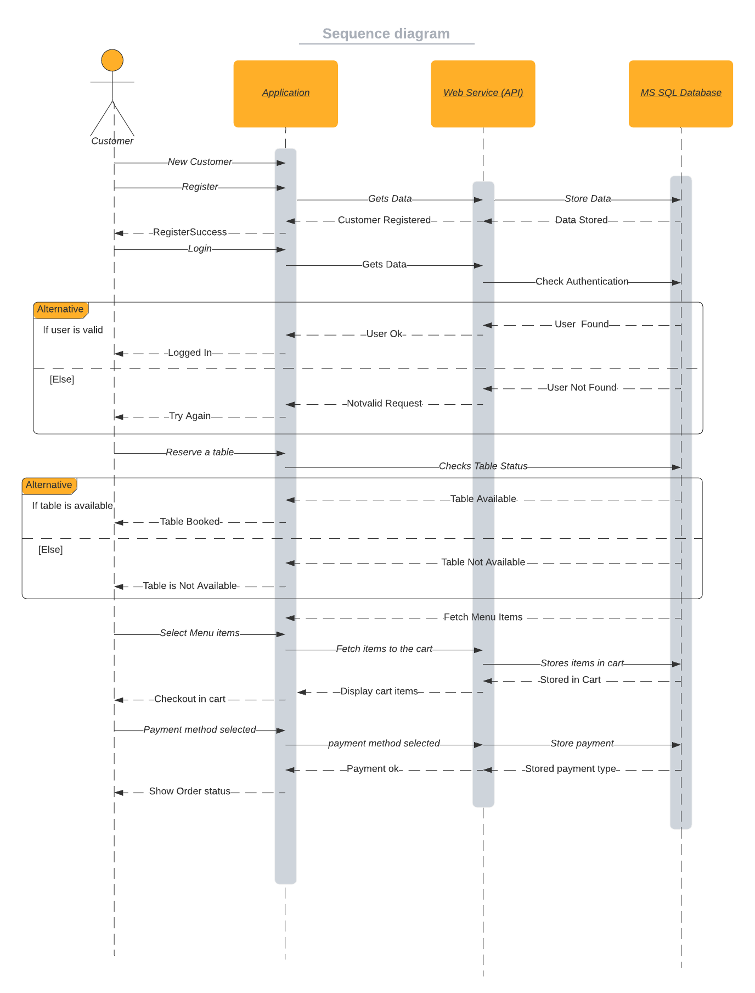

Figure 3: sequence diagram (Customer)

## 6.2) Manager

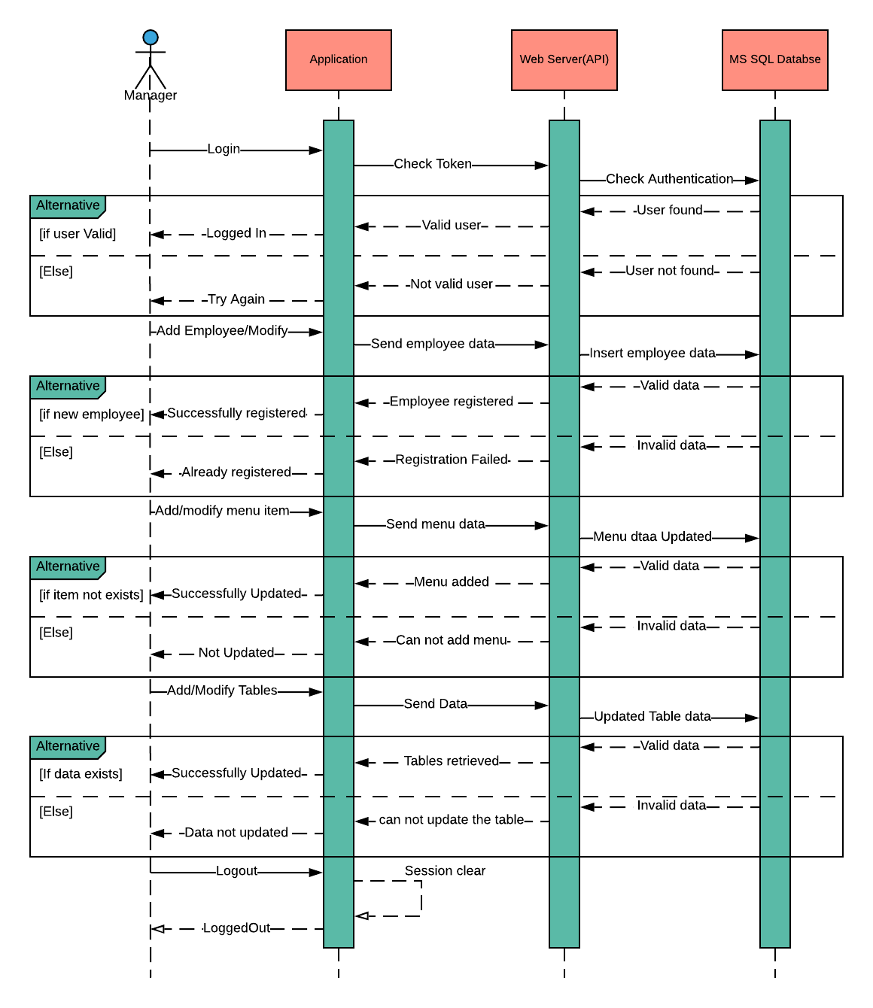

Figure 4: sequence diagram (Manager)

## 6.2) Chef

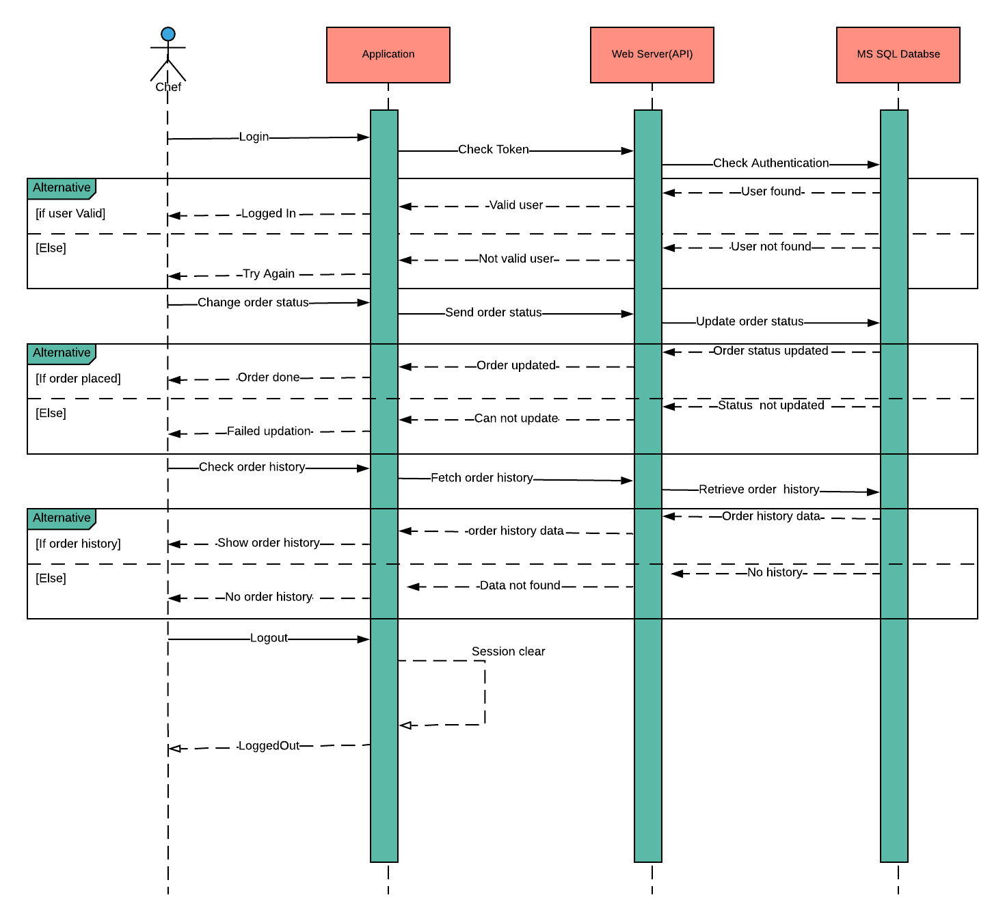

Figure 5: sequence diagram (Chef)

## 6.4) Cashier

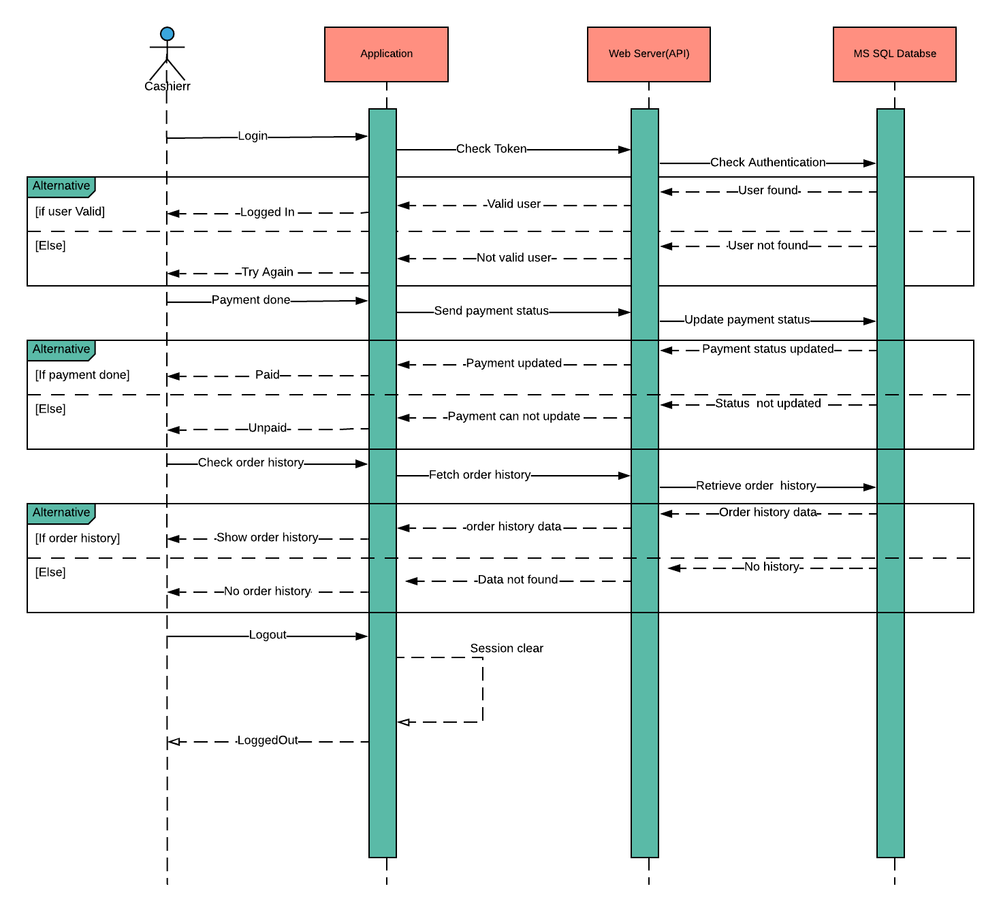

Figure 6: sequence diagram (cashier)

# **7) Activity Diagram**

## 7.1) Customer

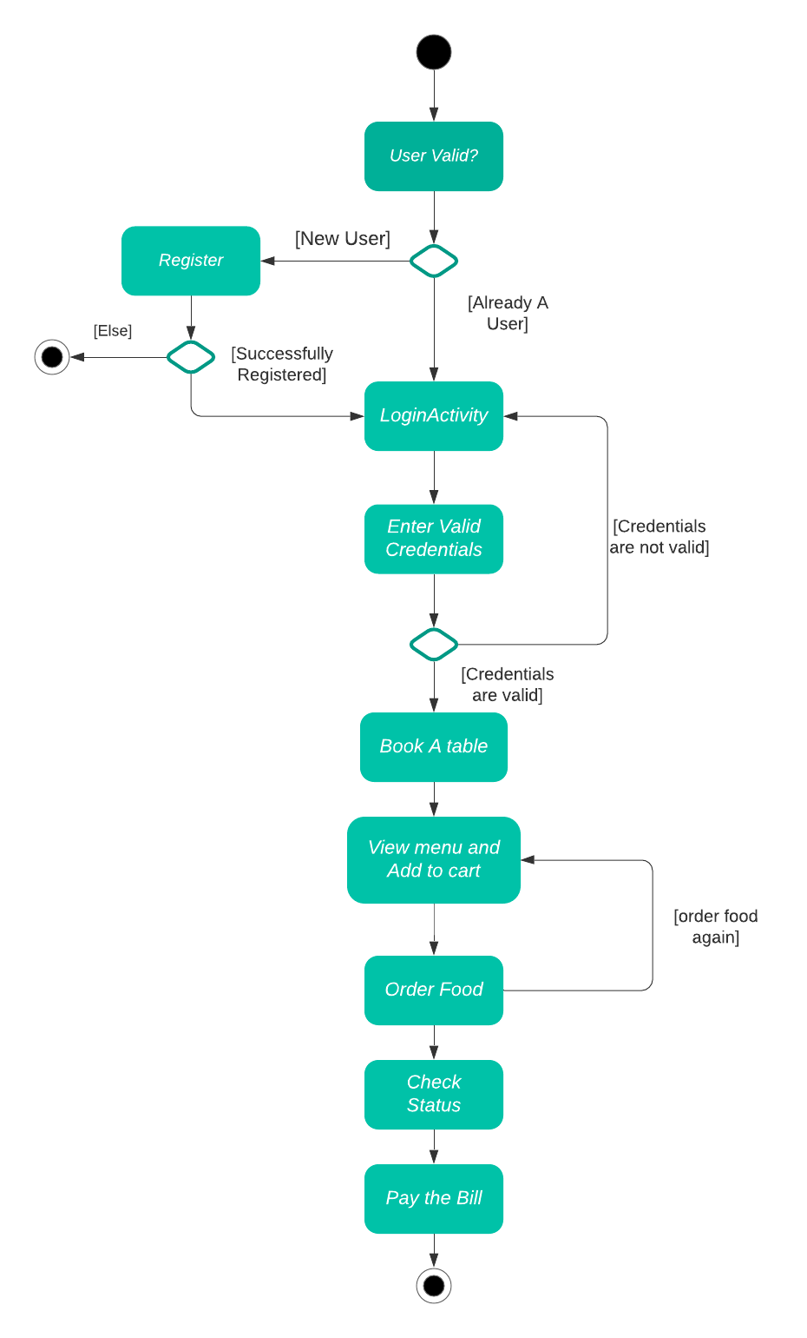

## 

Figure 7: activity diagram (Customer)

## 7.2) Employee

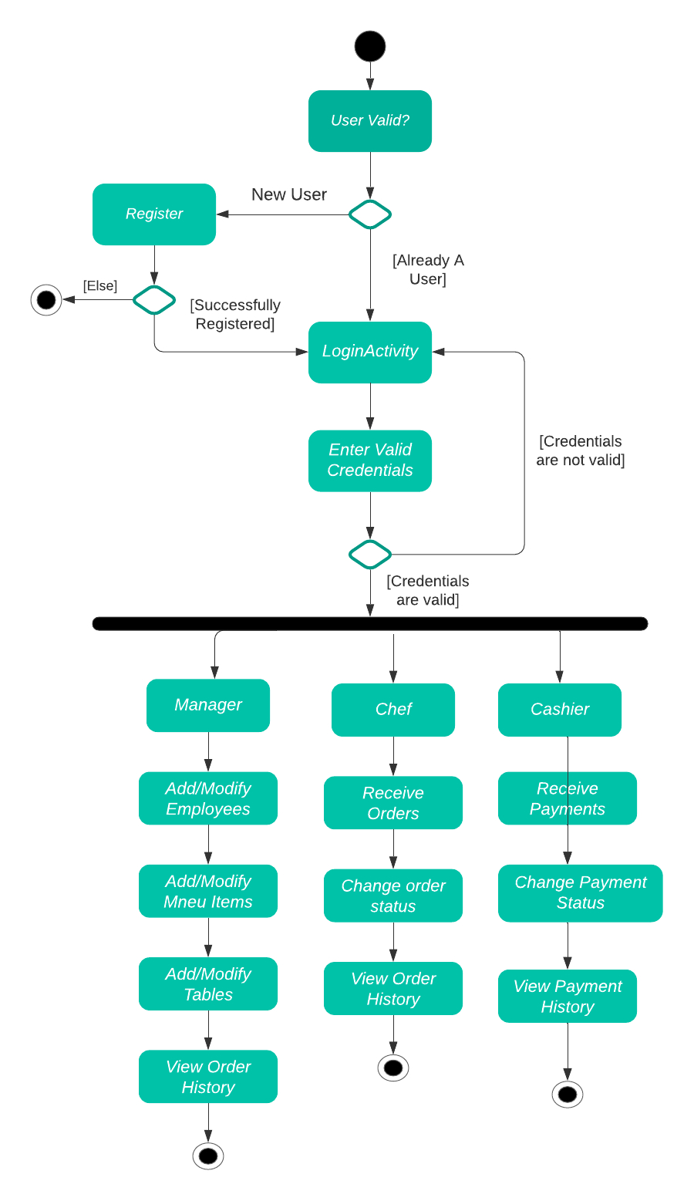

Figure 8: activity diagram (employee)

# **8) Mock-ups**

## 8.1) Customer side

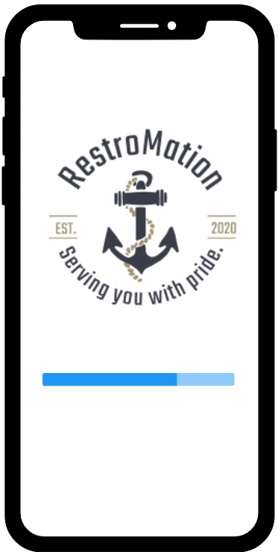 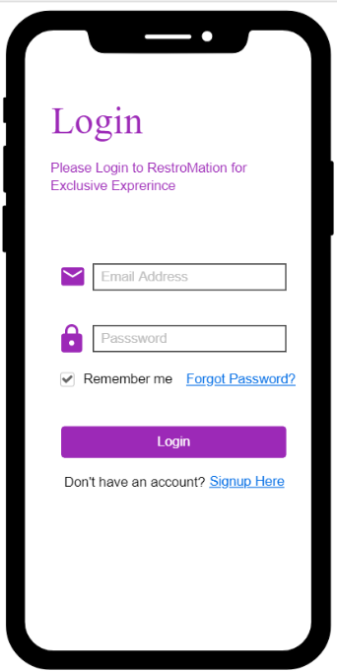

Figure 9: splash screen

### 8.1.1) Splash Screen

Splash screen whenever app is opened.

### 8.1.2) Login Screen

The customer and employee can login into the system through login screen.

Figure 10: Login screen

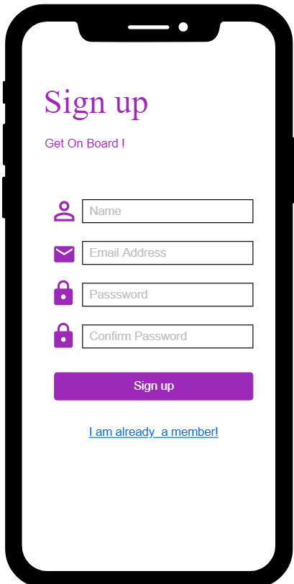 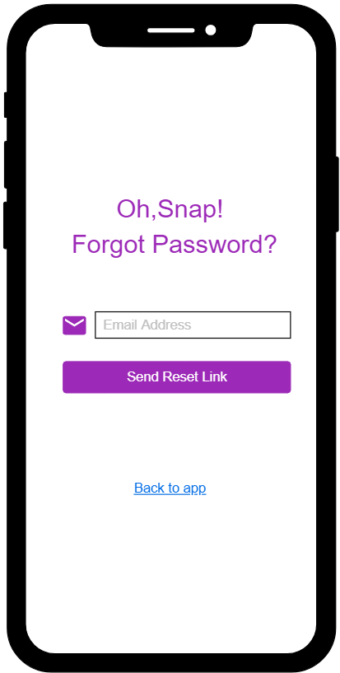

### 8.1.3) Forgot Password

Customer and employee can recover their new password in case they forgot the current password.

### 8.1.4) Register Screen

Customer can able to register into the system with their legit credentials.

Figure 11: Register Screen

Figure 12: Forgot password

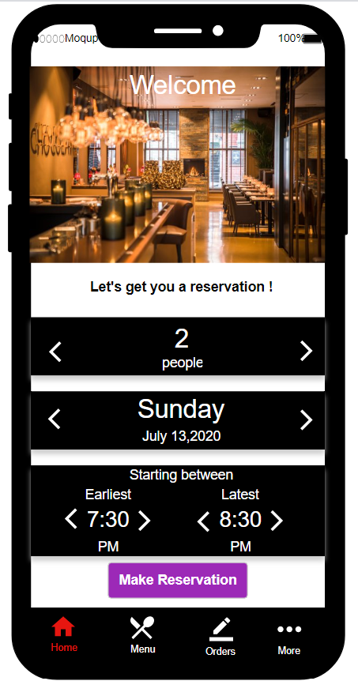

### 8.1.5) Reservation Screen

Customer would able to book table and see if table is available.

Figure 13: Reservation screen

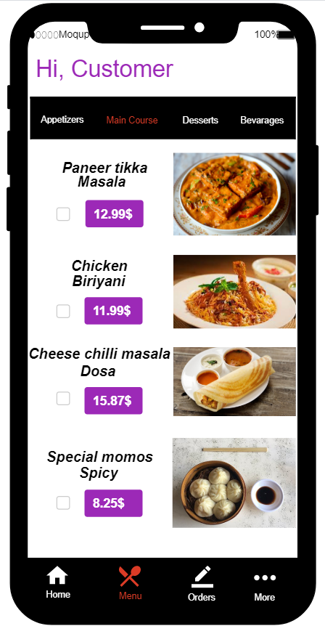       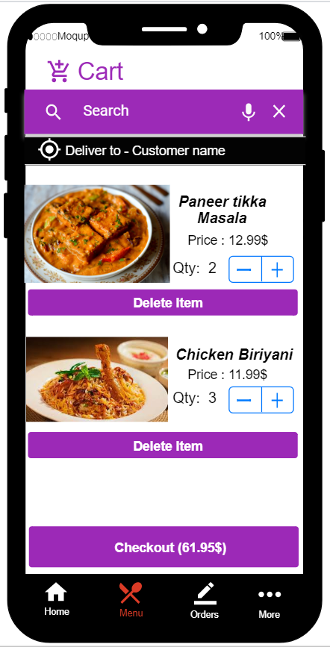

### 8.1.6) Cart

Customer would able to see all the selected items & their quantity, and processed further for confirmation.

### 8.1.7) Menu Items

Customer would able to see all the menu items and able to select the quantity to order food.

Figure 14: menu items

Figure 15: Cart

#### 

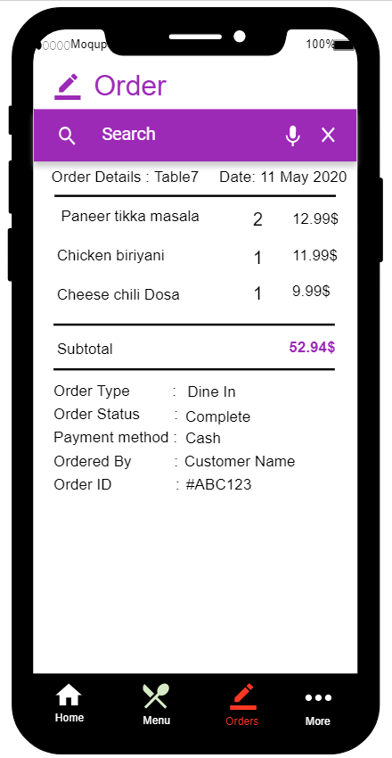   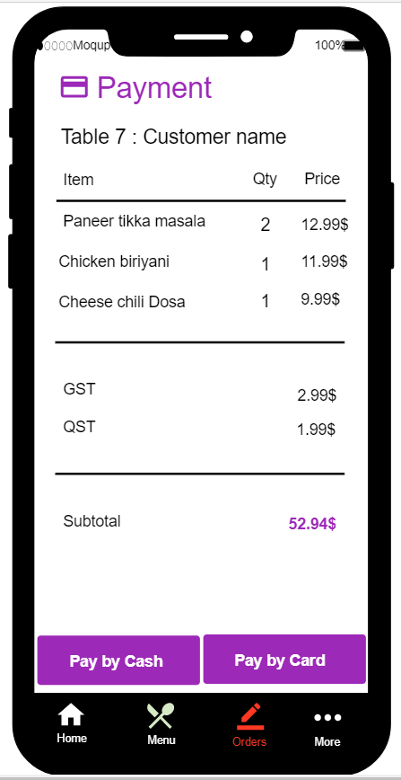

#### 

### 8.1.8) Payment screen

Customer can select the payment option and

### 8.1.9) Order History

Customer would able to see the history of their orders.

Figure 16: order history

Figure 17: payment screen

## 8.2) Manager Side

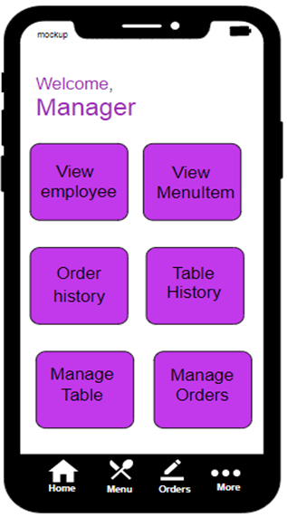 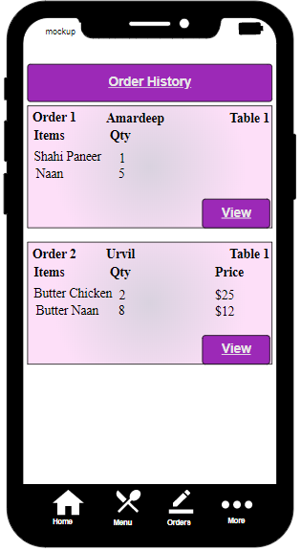

### 8.2.1) Manager Dashboard

Manager gets the multiple option to perform their task from the application.

### 8.2.2) Order history

Manager can see all the orders done by every customer in the restaurant.

Figure 18: manager dashboard

Figure 19: order history

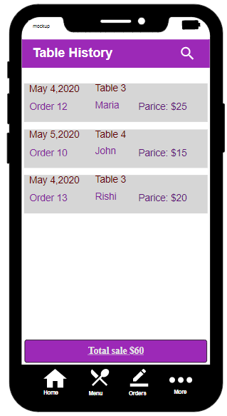 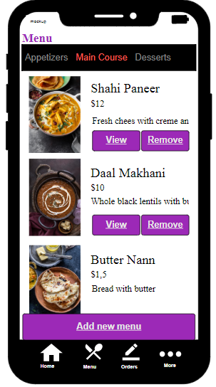

#### 

### 8.2.3) Menu items

Manager would able to see all the menu items and manipulate the menu by adding or removing item.

### 8.2.4) Table History

Manager can see the table booking history done by every customer.

Figure 20: table history

Figure 21: menu item

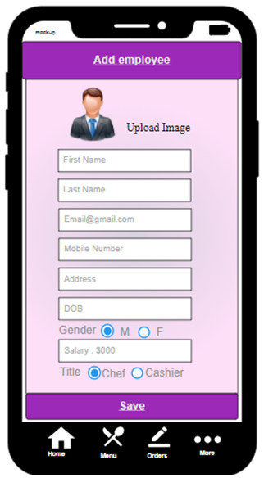   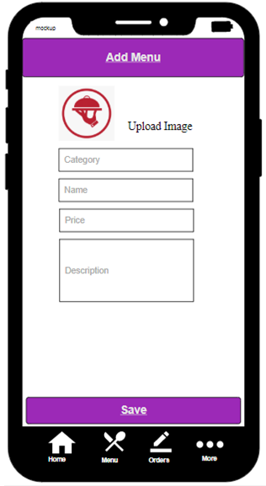

#### 

### 8.2.5) Add Menu Item

Manager would able to add menu item into the system.

### 8.2.6) Add employee

Manager would able to register a new employee for the restaurant into the system.

Figure 22: Add employee

Figure 23: Add menu Item

# **9) Class Diagram**

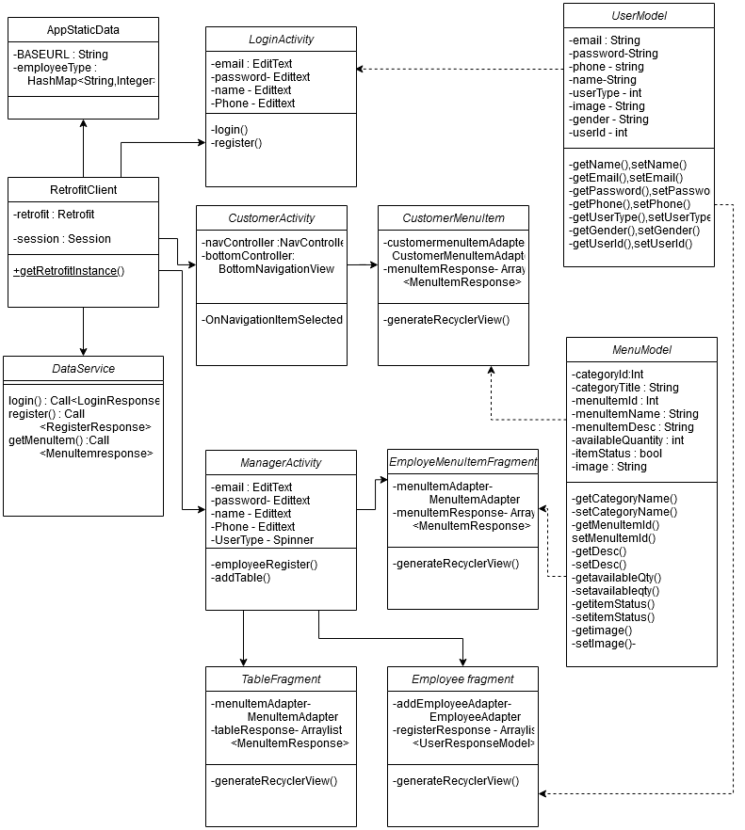

Figure 24: Class Diagram

# **10) Database Schema Diagram**

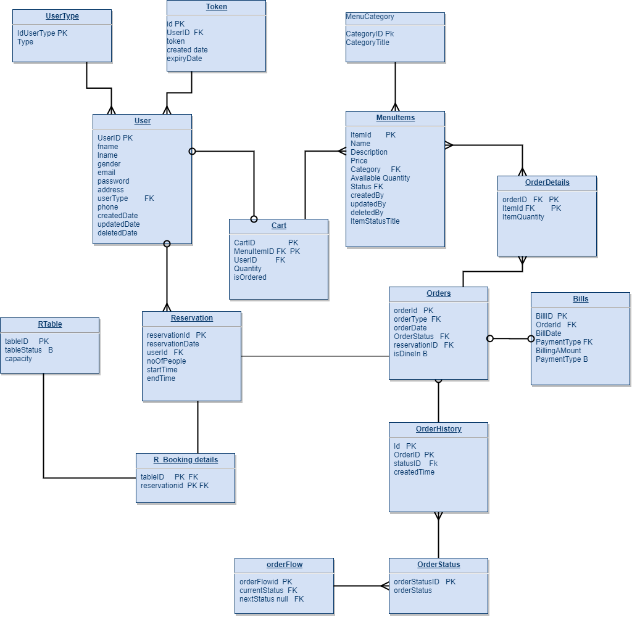

Figure 25: Database Schema Diagram